**FALL DETECTION WITH MS KINECT**

It is a computer vision based system, which develops a fall detection system with Microsoft Kinect 2. This system uses a camera to detect those falls through mathematical algorithms and get specific motion gradient data in the 3D space.

In order to develop the system, it is being used what follows:

* Qt Creator 4.0.2 (MSVC 2013)
* Kinect Version 2
* Open CV 3.2 with contrib
* Viz 7.1.1

These are the next tasks with status:

|  |  |
| --- | --- |
| TASK | STATUS |
| Installation and setting of QT Creator + Open CV with contrib + MS Kinect. | Done |
| Showing and processing 3D points with Viz module. | Done |
| Getting colour and depth images from Kinect. | Done |
| Processing point cloud from Kinect and showing 3D images with Viz. | Currently working on it |
| Estimation of ground. | Not yet |
| Implementation of a body skeleton detection. | Not yet |
| Implementation of fall detection system through mathematical algorithms (position, velocity). | Not yet |

QT Creator is the platform I am working on with C++, where It is expected to call the Kinect functions to get images (through the Kinect sensors and camera) and the Open CV libraries to use Viz module to get, which allows us to work with point clouds.

At the moment, I am able to run Kinect sensors and Open CV modules in an independent source files, which means it is compiling successfully. However, my current problem is that I am not able to call and show the point cloud (generated by Kinect) using Viz modules (Kindly see the image below).

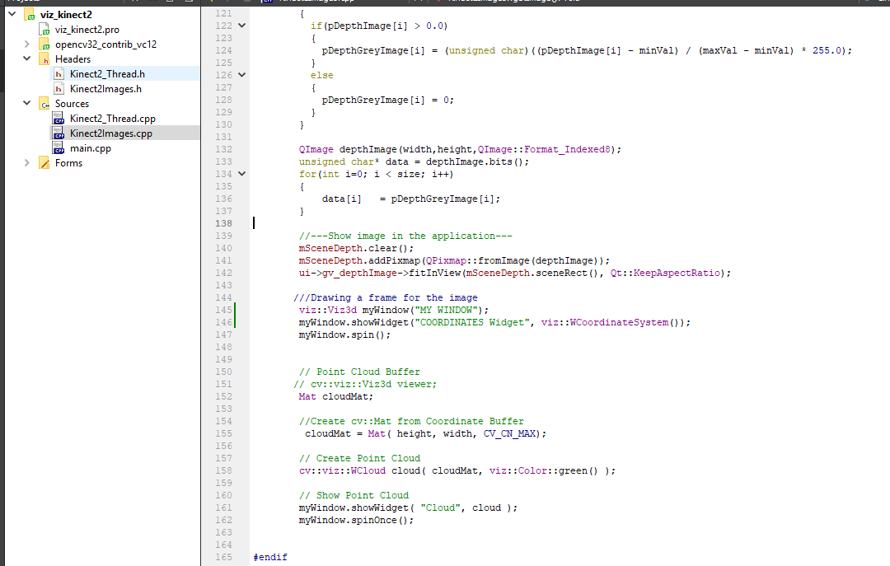

Unsuccessful attempt of getting the point cloud from Kinect with Viz

**QUESTIONS:**

* I am wondering if you could provide me an example or examples of showing point cloud generated by Kinect 2 by using Viz module as described.
* In the same way, I would appreciate if you provide ME some examples or information about the next tasks above mentioned.